Terraform:

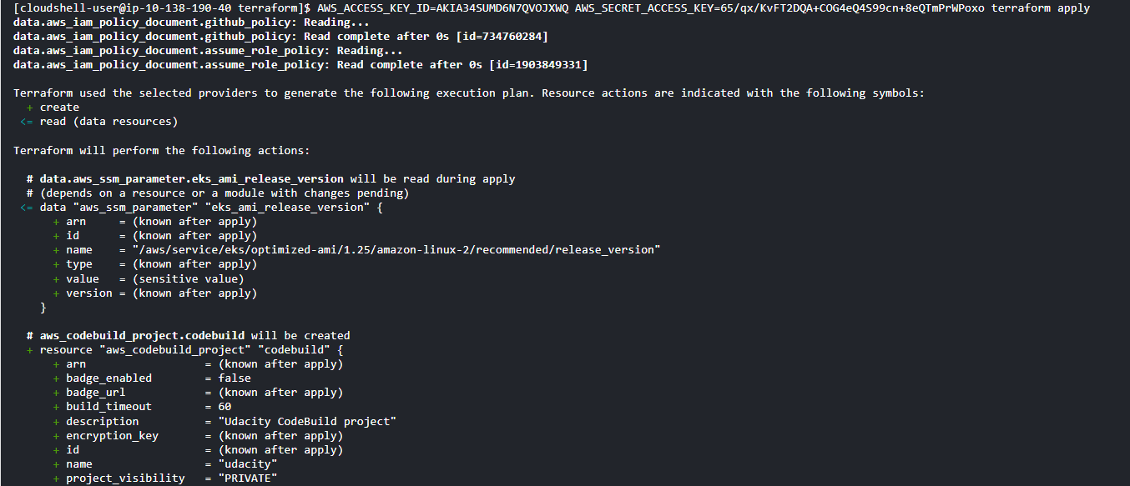

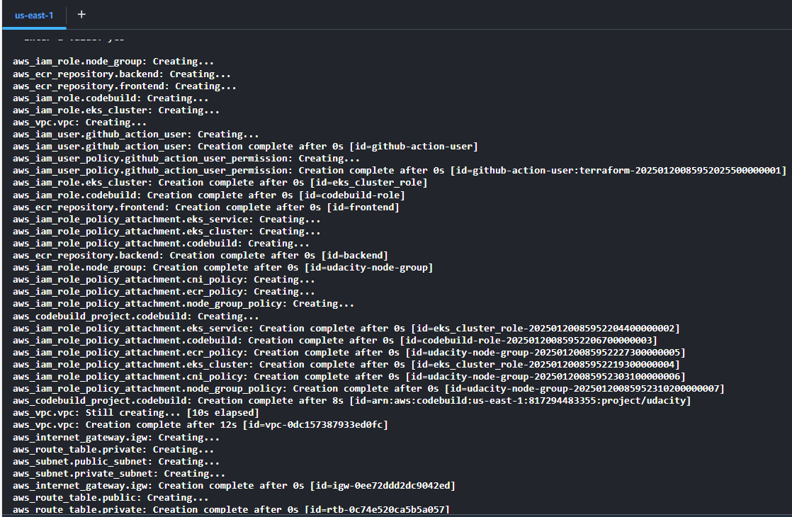

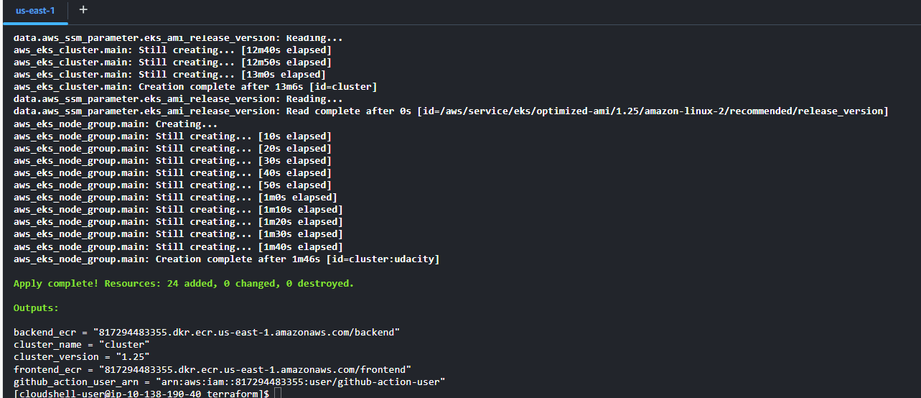

IAM github-action user:  
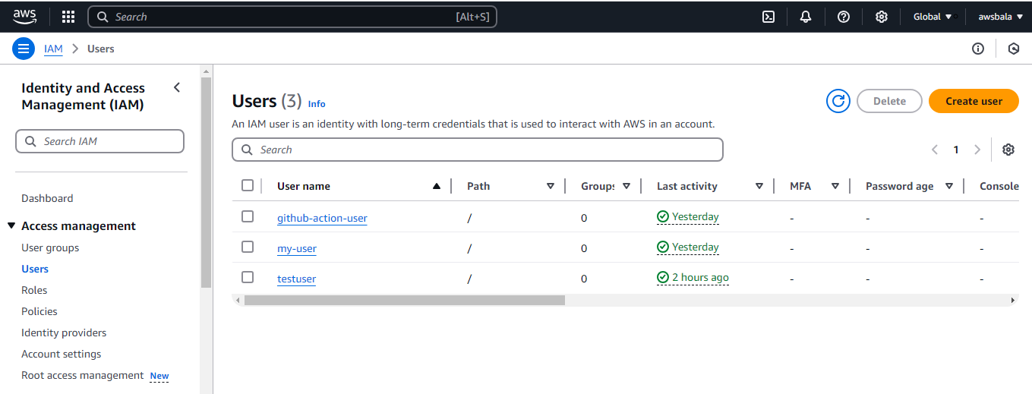

ECR repositories:

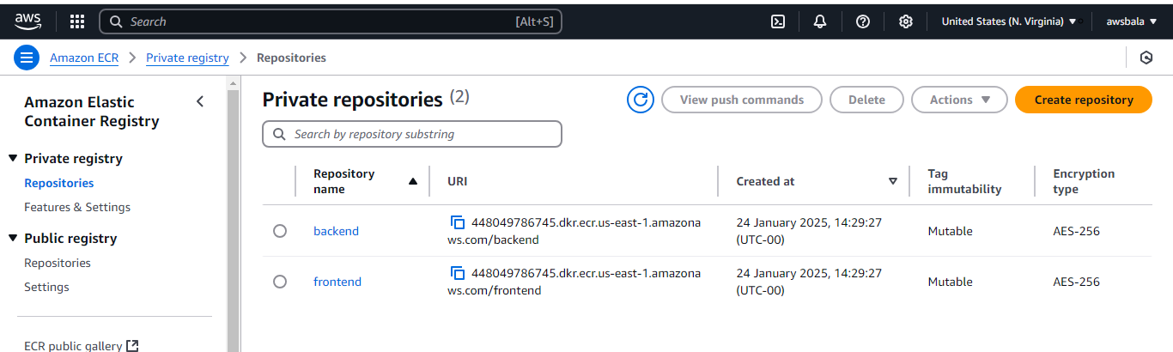

Github action url ref: <https://github.com/rbalarekha/Movie-Picture-CICDpipeline/actions>

Backendend image:

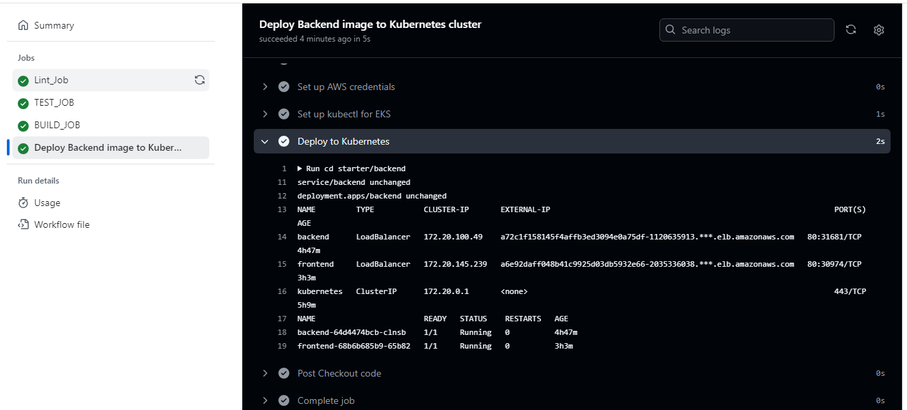

Frontend image:

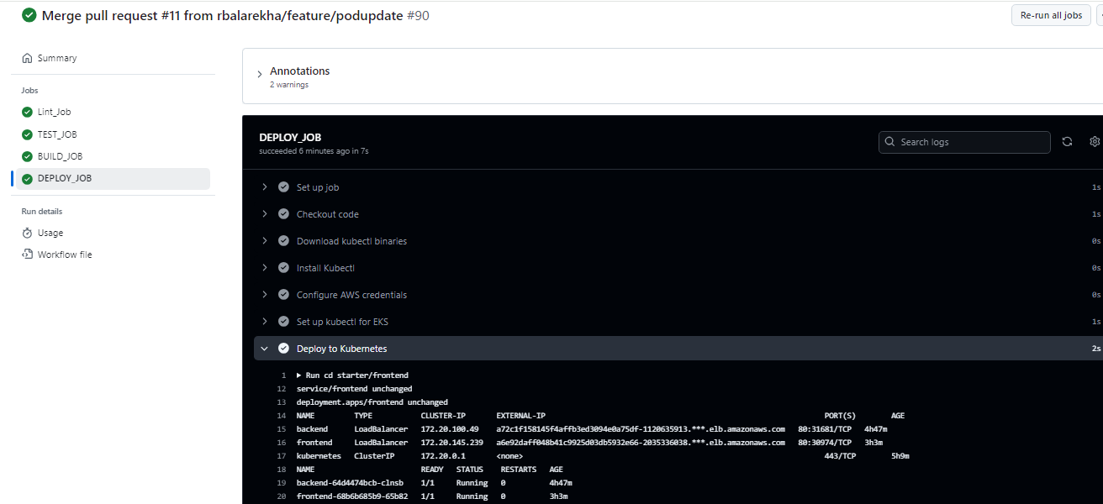

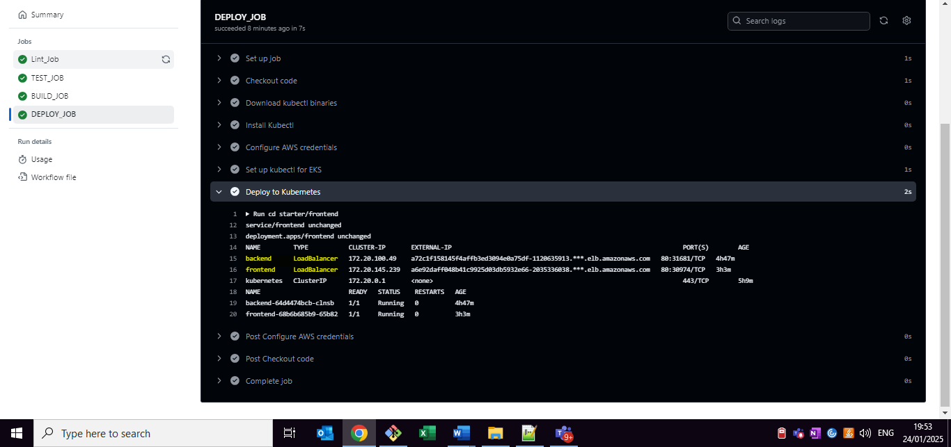

Frontend CI:

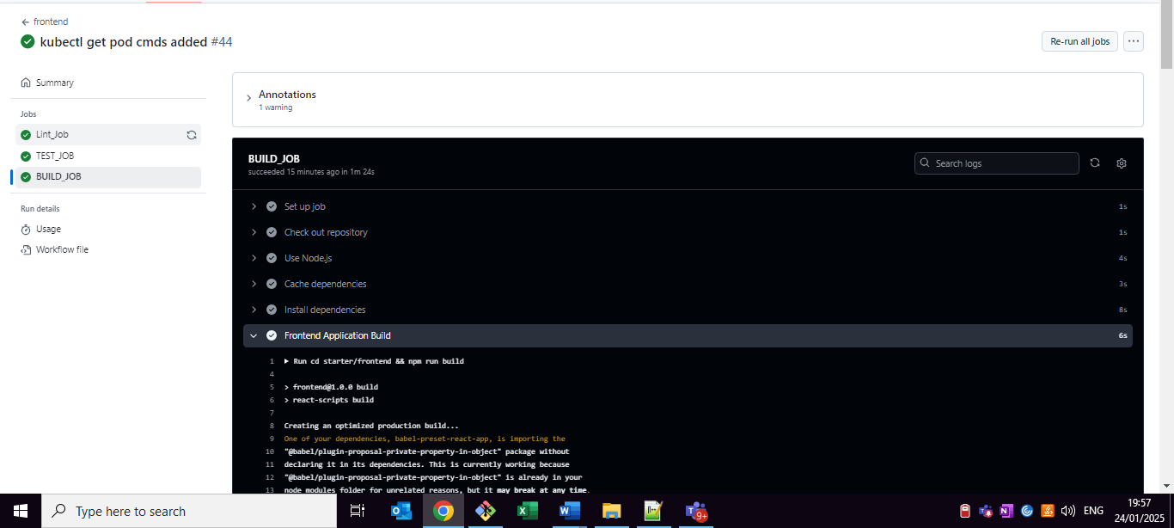

Backend CI:

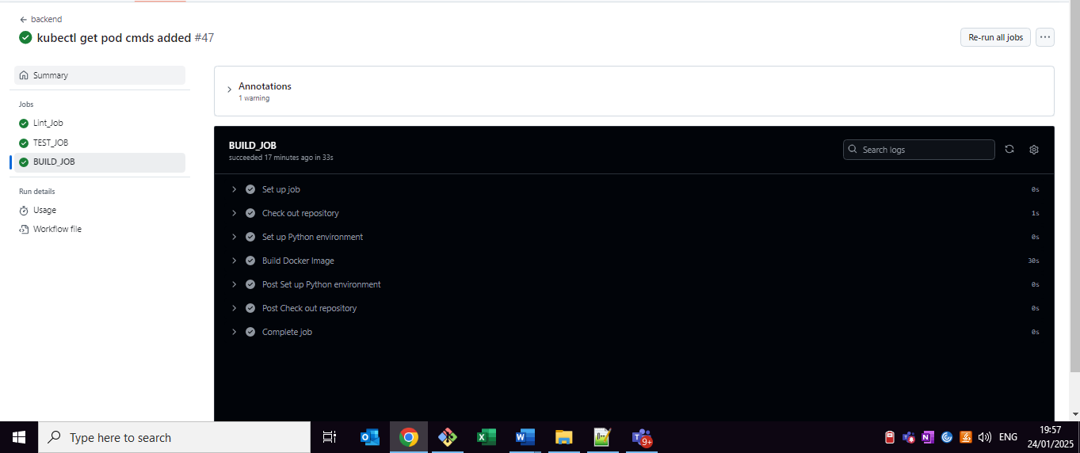

React App:

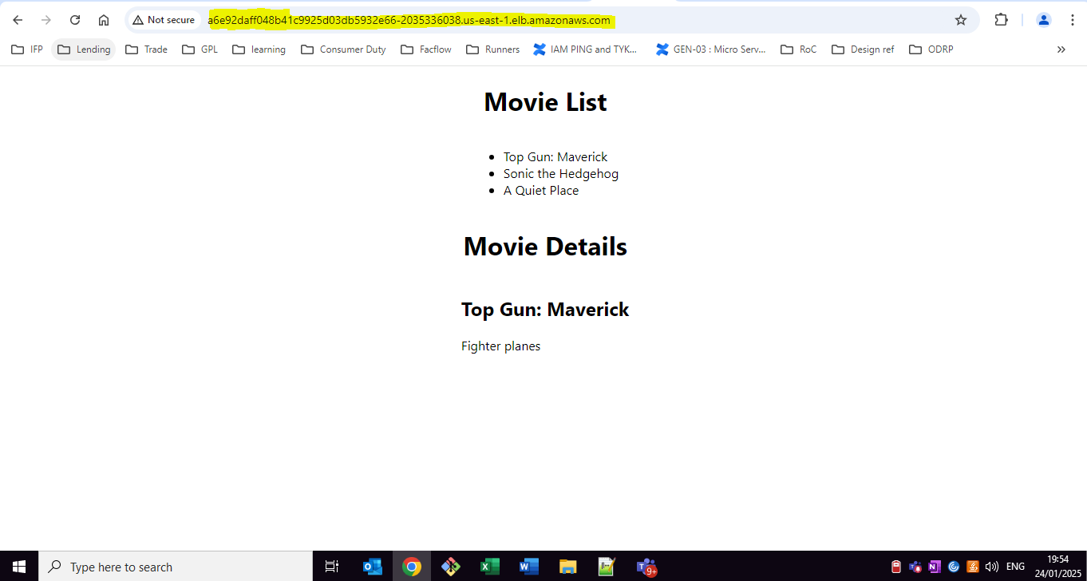

Review comment updates:

Fix the workflows triggers. CI is run for pull_request events and CD is run on push events.

Ans: Both CI & CD workflow has already configured with the pull [for CI], push [for CD] events.

I have triggered the work flow and pls refer the screenshot ref:

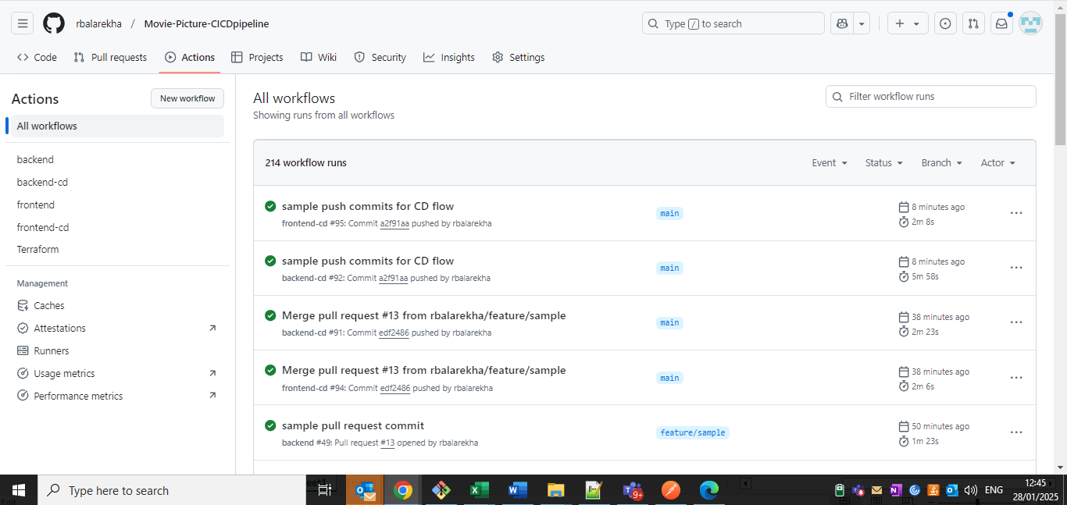

* Redeploy the services and share the Frontend and Backend service URLs after the completion of the. CD workflows. This is to required to validate your deployments.

Ans:

Backend ref: <http://a85b8f0f863e84170ac5fbf3c337b559-2092168897.us-east-1.elb.amazonaws.com/movies>

Frontend ref: <http://a9ed5c08e8ada4814b1b5e11d303164e-1890671419.us-east-1.elb.amazonaws.com/>

Screenshots:

Backend ref:

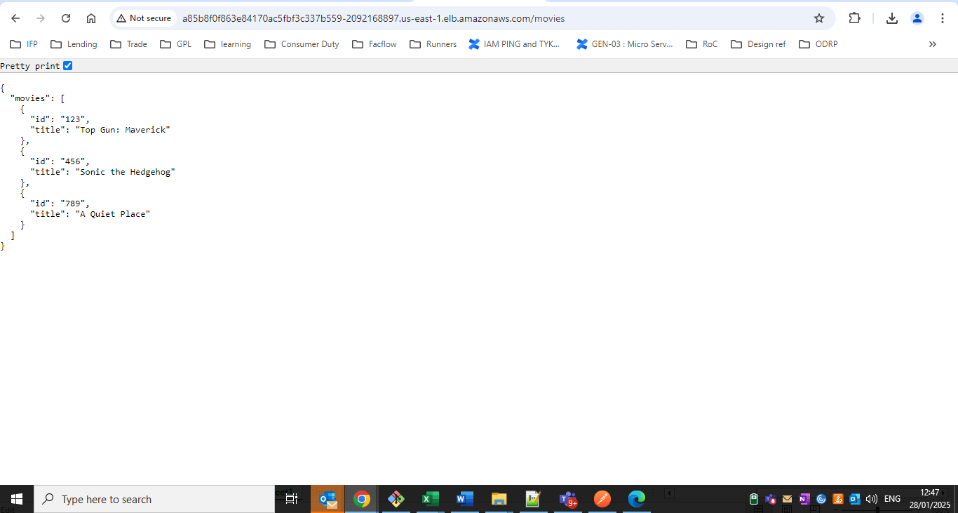

Frontend ref:

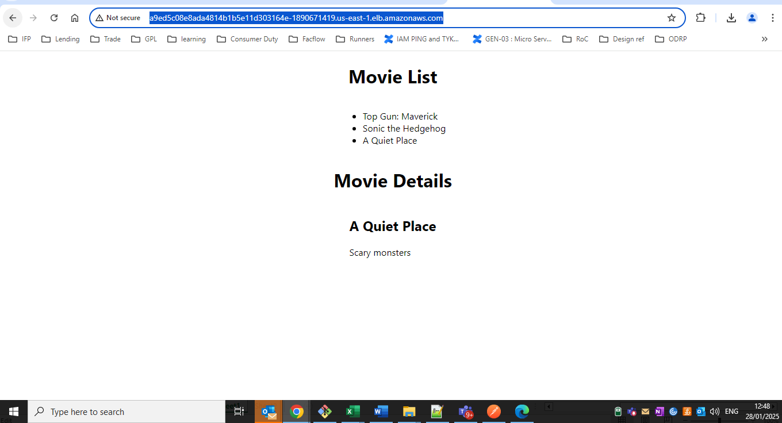

Workflow Trigger:

Backend:  
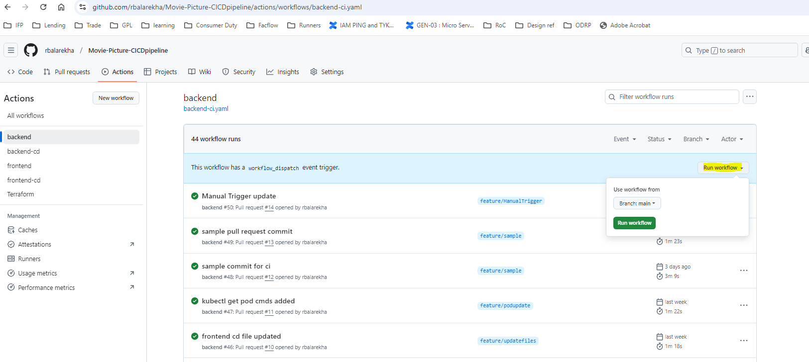

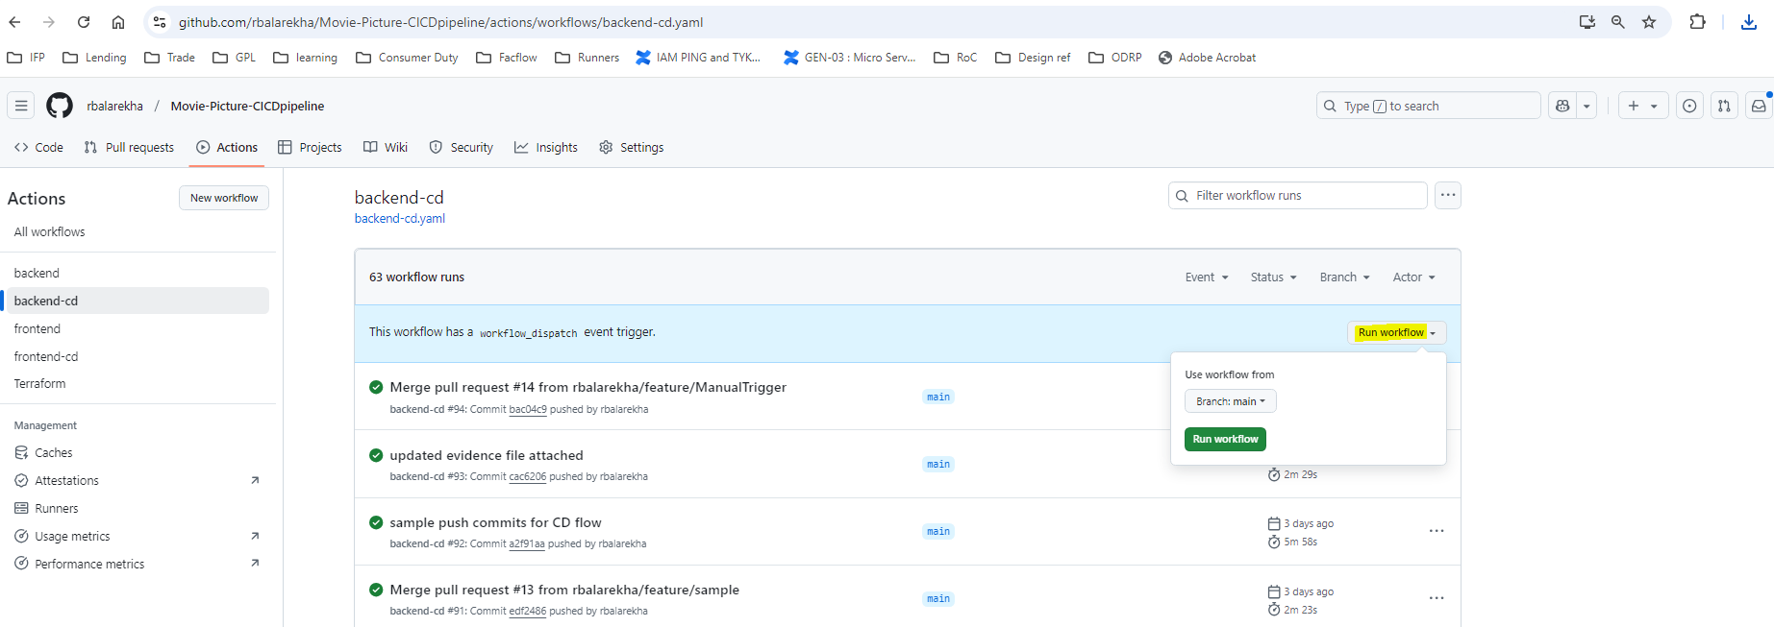

Frontend:

